# Lab 1 Structural Report

Academic Integrity (more info @ https://aisc.uci.edu/): You are encouraged to discuss the labs at a high level, but the code/equations/simulations you come up with should be your own. By typing “yes” at the end of this question and filling in your name, you certify that the work you are turning in is your own work. Is the work you are turning in your own? **_yes__**

If you worked on any portion of your report or vhdl code with other students (discussion at high level & debugging; if more, please describe), please list their names here. Otherwise write “n/a”: **_n/a___**

Student Name: **Christopher Cyr**  
Student ID: 12436037  
Date Completed: 4/22/22  
Time Spent: Reviewing Digital Design Material: 5 min  
 Design/Preparation Work: 5 min  
 VHDL Coding & Debugging: 10 min

## Structural Overview

What % do you feel you completed the lab. Be sure to list your general procedure of how you completed this lab & material (if any) you reviewed to help you complete this lab. Regardless of % stated, provide any details of difficulties (if any) you encountered during this lab. A few sentences are sufficient.

100%. I tried several things to figure out the syntax but once I got it the rest was easy

## Lab 1 NAND Equation

Show the work you did to go from your minimized equation to final structural equation here. Be sure to represent the equation with only 2-input NAND’s in mind for full credit.

F = (Fuel3 + Fuel2)’

F = (((F3F3)’(F2F2)’)’((F3F3)’(F2F2)’)’)’

## Lab 1 Circuit and Input-to-Output Delay

Provide a drawing/figure/circuit of your final structural equation in terms of gates here. You can use Visio or other gate drawing software here or attach a picture of your circuit as long as it is legible.

Delay of circuit: _4.2__ ns  
Cost of circuit: __16_ transistors

Comparison of delay & estimated cost between behavioral & structural design:

2.8ns longer delay for structural and 12 more transistors for structural

## Lab 1 Structural Simulation Graph

Show a screenshot of your final graph here. You should crop it to the appropriate size so that it is legible.

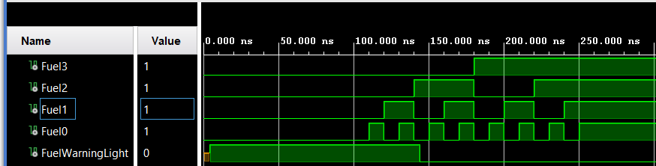

## Lab 1 Structural and Behavioral Simulation Graph Comparisons

Compare your behavioral & structural graphs here. If there are any differences (delays, outputs, etc.), be sure to explain them here.

Because delay was not included, the graphs are identical